In the instance of instructor shown in Figure 2.1, no two instructors have the same name. From this, can we conclude that name can be used as a super key (or primary key) of instructor?

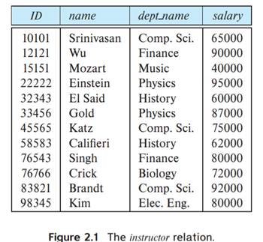

Step 1:

A superkey in the relational data architecture is a collection of qualities that each tuple in a connection is uniquely identified by. Tuples with the same superkey value must also have the same non-key attribute values since superkey values are unique. In other words, non-key qualities rely on the superkey in order to work.

The column or columns that each row in a table uses to uniquely identify itself is known as the primary key. For Optim to insert, update, restore, or delete data from a database table, the table must contain a primary key.

Step 2:

No. The names in this particular instance of the teacher table are unique, although this may not always be the case in general (unless the university has a rule that two instructors cannot have the same name, which is a rather unlikey scenario).